Candidate pack
Finance Manager, Financial Liabilities

Contents
Welcome letter 3
NHS Resolution 4
Our values 4
Job description 5
Benefits 9

Welcome letter

Dear Applicant,
Thank you for your interest in the position of Finance Manager, Financial Liabilities at NHS Resolution. This is an exciting opportunity to join a dynamic and innovative organisation that is committed to improving patient safety and quality of care.
NHS Resolution is an arm’s-length body of the Department of Health and Social Care. We provide expertise to the NHS on resolving concerns and disputes fairly, sharing learning for improvement and preserving resources for patient care.
As the Finance Manager, Financial Liabilities, you will be responsible for delivering high-quality financial reporting, forecasting and analysis for financial liabilities (reserves) within NHS Resolution’s indemnity schemes. You will also support the development and implementation of financial policies and processes to ensure effective financial management and governance.
In this job pack, you will find more information about NHS Resolution, the role and the person specification. You will also find details on how to apply, the selection process and the benefits of working for us.
We are looking for candidates who share our vision, values and objectives and who have the right background, experience, skills, qualifications and motivation to make a positive difference. If you think you are the right person for this role, we encourage you to submit your application by Monday 16th June 2025
If you have any questions or need any assistance with your application, please do not hesitate to contact us.
We hope you find this job pack useful and informative. We look forward to receiving your application soon.
Kind regards,

Hamid Khan
Head of Financial Liabilities

NHS Resolution
Delivering fair resolution and learning from harm.
To provide expert advice to the NHS and the wider system on resolving concerns fairly. In doing so, benefit patients by preserving funds for healthcare and sharing learning for improvement.
Healthcare in the NHS is very safe but on the rare occasions when things go wrong, or there are concerns about clinicians in practice, it is important that those involved are properly informed and supported, unnecessary costs are contained and that we learn to improve.
Compensation arises not just for clinical errors, but also for injuries to employees and members of the public who are injured in the course of their employment or in accidents on NHS premises. Healthcare staff can be deeply affected when they are involved in an incident. The indemnity schemes we run serve the purpose of minimising unnecessary cost and spreading this over time by providing economies of scale and the best possible value in expert management of claims for compensation. This ultimately protects patients by preserving funds for healthcare.

Our values
Our PEER (Professional, Expert, Ethical Respectful) values reflect how we work, how we want to treat each other and those we work with
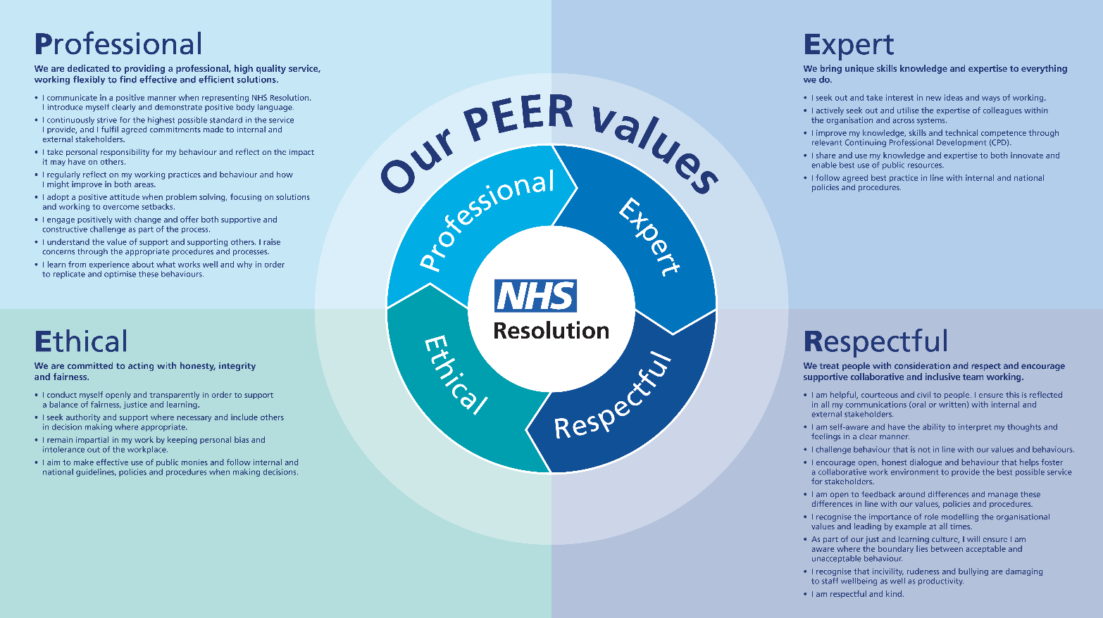

Job description
Finance Manager, Financial Liabilities

Reporting to: | Head of Financial Liabilities
Direct reports: | n/a
Band: | 8a
Hours: | 37.5
Location: | Leeds/Hybrid

NHS Resolution
NHS Resolution provides indemnity arrangements for NHS secondary and general practice provision, several arms-length bodies, and a number of independent sector providers of health care. The eleven schemes, governed by Regulations, provide indemnity cover for both clinical and non-clinical negligence.
Background
The Finance - Indemnity Schemes team (FIS) is a niche, specialist team within NHS Resolution. Responsibilities within the FIS are shared by two sub-teams, the Financial Liabilities and Pricing teams.
The FIS team leads key high-profile activities for the organisation.
- It is instrumental in the valuation of its financial liabilities for scheme provisions. It leads this process along with the forecasting, critical analysis, and insights into its provisions, identifying risks and trends, etc.
- The team also leads the budgeting process for the organisation’s expenditure on indemnity schemes. This includes pricing for our member funded schemes and setting contributions for scheme members.
These processes involve close working with our actuarial partners, the Government Actuary's Department, carrying out data analysis, establishing financial assumptions, asking challenging questions and providing insights.
Job purpose
This role manages the valuation of the indemnity scheme provisions, which are unique and central to NHS Resolution.
The role involves handling, modelling, and analysing complex data sets, working with actuarial advisers (including Government Actuary’s Department - GAD) and other experts, and reporting the best estimate of the scheme liabilities. The role also requires complex analysis to understand variances, trends, and risks, and to support decision making and project work. The role needs a strong financial accountant with excellent analytical, modelling, forecasting and interpretation skills.
Main responsibilities
- Manage and coordinate month end activities within the team and the engagement with wider finance teams to deliver a timely and accurate month-end result on provisions coupled with delivering useful insight.

- Partner with key stakeholders such as the actuarial adviser (Government Actuary’s Department), internal functions (Claims, Early Notification, Policy, Business Intelligence and Digital, Data and Technology, and Transformation) to leverage knowledge and expertise to deliver high quality financial management and reporting for Financial Liabilities under the indemnity schemes.

- Support development of the provisioning workplan for the year with key stakeholders, coordinating the Reserving and Pricing Committee (a Board subcommittee) and working group meetings, to ensure that the key inputs and outputs from the meetings are delivered in a timely way to a high standard.

- Complete calculation of the known claims provision, based on information from the claims system and working with actuaries on applying the highly complex assumptions for forecasting and for inclusion in the statutory accounts, along with the analytical review on provision movements, supporting analysis sensitivities, insights, and commentary on the provision calculations for the Annual Report and Accounts.

- Support the year-end audit by dealing with internal and external queries and ensuring audit actions and recommendations are appropriately dealt with in a timely manner.

- Complete modelling for regular BAU delivery and or for ad hoc analysis as required within the team coupled with contributing to assurance activities.

- Develop efficient and effective controls and financial modelling to deliver useful analysis and insights on actual performance and forecasts whilst ensuring consistency of financials and the storyline.

- Understand the risks to data quality, apply appropriate approaches to test validity of data inputs and apply appropriate methodology to ensure estimates are in line with accounting standards and circumstances arising from NHS Resolution’s activities in the preparation of indemnity scheme provisions and forecasts.

- Develop financial and analytical approaches to scheme provision modelling and applying the most appropriate tools including Agile and Lean techniques for the changing environment.

- Support existing and new projects and manage change as required by the organisation to ensure the organisation can meet its stakeholder expectations.
- The post holder will be required to deputise for the Head of Financial Liabilities as needed.

Working relationships and contacts
Key stakeholders
- Actuarial adviser (Government Actuary’s Department)
- Internal functions (Claims, Early Notification, Policy, Business Intelligence and Digital, Data and Technology, and Transformation)
- Reserving and Pricing Committee (a Board subcommittee)
- Claims team
Team structure

Person specification
Finance Manager, Financial Liabilities
Key experience, skills and qualifications
- This is a specialist and complex area and requires a high level of acumen to understand interconnecting links, complicated and intricate aspects of the schemes and the impact of changes. The post holder will need to be able to interpret, draw insights and ask challenging questions, assess issues, anticipate problems, and provide workable solutions.
- ACA/CIMA/ACCA qualification with proven finance experience.
- Core finance experience or equivalent reserving experience is a must.
- Highly numerate with excellent analytical skills and an ability to manage and analyse large and complex data sets.
- Have built and have developed complex forecasting and analytical models, including and scenario modelling
- Used to working with complex and intricate multi-faceted pricing models
- Excellent IT skills including advanced Excel skills
- Excellent written and verbal communication skills
- Experience in producing clear and understandable financial information, reports, and analysis
- A proactive and adaptable approach, able to multi-task able and manage multiple competing priorities, and to plan and deliver to deadlines in a fast paced and quick turnaround environment
- Experience of developing systems to bring together, analyse and present data and information relating to large datasets and incomplete information, to create insight for decision making
- Experience of dealing with internal and external auditors
- Curious mindset, proactive, problem solver
- Attention to detail whilst being able to see the big picture
- Sets high standards with a best practice approach
- Committed to own professional development and expanding personal knowledge of commercial indemnity environments
The successful candidate will have the opportunity to play a key role in the development of a growing organisation in a fulfilling, interesting and stimulating role.
To apply please include a covering letter highlighting what you will bring to this role in terms of your background, experience, skills and career achievements to date by Sunday 15th June, 2025.
The selection process will include an initial informal discussion followed by a formal interview via Teams. Details will be shared with candidates beforehand.

Benefits
Annual leave
The annual leave year runs from 1st April until 31st March. Full-time staff are entitled to 27 days plus 8 bank holidays. Employees are awarded additional annual leave after 5 and 10 years of NHS service. If you work part time, then your annual leave will be pro rata.
Flexible working
We offer employees the option to consider work flexible – this could include doing flexitime, homeworking, compressed hours, part-time working, job sharing and unpaid employment.
Pension scheme
We offer you the option to join one of the most generous and comprehensive pensions in the UK Automatic membership on joining NHS Resolution. Visit www.nhsbsa.nhs.uk/nhs-pensions for more information including pension estimates and contact details.
Additional benefits
- Cycle to work scheme - discounts on bicycles and cycling equipment through a salary sacrifice scheme
- Season ticket loan scheme - we can purchase an annual travel card, which staff can pay in monthly instalments, resulting in cost savings
- SpecSavers eye care voucher - a free eye test and £45 toward glasses (for VDU use)
- Health service discounts & HASSRA – offers great discounts for various high street stores, holiday packages, car maintenance
Employee Assistance Programme
Free advice and counselling on a variety of issues including health, family, work, finances, legal and retirement. Open to staff and their immediate family members.
Careers at NHS Resolution
For more information about careers at NHS Resolution, please click here: NHS Resolution: Life | LinkedIn

