JOB DESCRIPTION

Job Title: Senior Data Scientist

Pay Band: AfC 8a

Hours: 37.5

Accountable to: Data Science Manager

Location: NHS Resolution London Offices

|  |  |
| --- | --- |
| Purpose:  Values: | The post holder is expected to fully understand, embrace and uphold NHS Resolution’s Purpose and Values:  *“To provide expertise to the NHS on resolving concerns fairly, share learning for improvement and preserve resources for patient care.”*  **Professional**  Being an organisation which operates to the highest possible professional standards.  **Expert**  Being the centre of expertise for resolving claims, disputes and concerns about performance.  **Ethical**  Having high standards and doing the right thing.  **Respectful**  Dealing with customers, colleagues, patients and the public in a considerate and respectful way. |

Key Working Relationships

*Internal*

* All NHS Resolution staff

*External*

* NHS Bodies
* Panel firms
* Arms’ Length Bodies
* Other external stakeholders

Job Summary

Reporting to the Data Science Manager, the post holder will provide expertise in Data Science and analytical methods to the whole organisation.

The senior data scientist will support, manage and lead a team of data scientists and act as a subject matter expert on the development of data science solutions using Python and Azure machine learning studio. The post holder will maintain a high level of engagement between the data scientists on the coordination of machine learning pipelines.

He/ she will assist the data science team in development of statistical and analytical best practices and apply these practices to complex NHSR datasets to deliver data insights.

The post holder will develop data science methodologies for ad-hoc analysis, insights work and for highly complex prediction and statistical models.

Organisation Chart

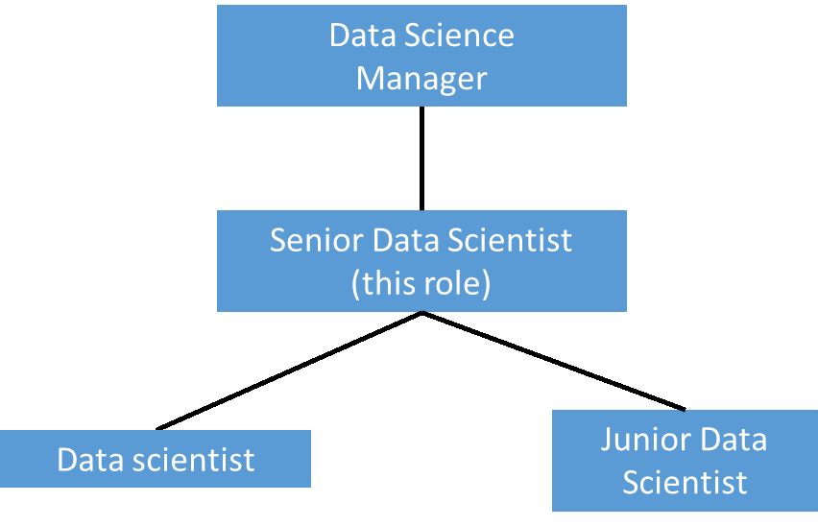

Main Duties and Responsibilities

Communicates Effectively

* Liaise with data scientists and track work progress on multiple concurrent projects.
* Communicate with the Data Science Team and other parts of the BI team to coordinate development of data sources, data features, data science solutions and pipelines, maintain a good communication channel establishing strong links to support developments.
* Liaise with stakeholders to understand complex and difficult problems within NHSR.
* Manage the sensitive communication of extremely complex and potentially highly contentious information such as that from the clinical negligence schemes, early notification scheme data, safety and learning data, personal patient data, and personal practitioner data
* Liaise with internal and external stakeholders in an interactive fashion to develop learnings across the healthcare system across NHSR and other Trusts.
* Work in collaboration with subject matter experts, external actuaries, researchers and data scientists to develop new metrics and reports to assist with measuring performance, quality, financial and other issues.
* Communicate highly complex findings effectively both orally and visually to drive the right actions and outcomes from the analytical insight. Tell compelling, clear and actionable stories relevant for business goals using the most appropriate medium to visualise the data. This will include presentations to Board, Senior Management Team (SMT), and to operational, non-IT specialists.
* Together with the Data Science Manager, responsible for delivering training and project presentations to Senior Management Team, BI team, the broader DDaT team and the wider organisation on a regular basis.
* Manage communication of findings to safety and learning team, summarising lessons learned from the data to improve patient outcomes and patient care.

**Analytical and Judgmental Skills**

* Undertake exploratory data analysis to analyse, understand and present different analytical, statistical and machine learning methods to answer questions from Claims and Advice teams, including potential ways of improving the utility of datasets with data quality issues.
* Contribute to the development of statistical, mathematical and predictive modelling for such highly complex issues as claim value prediction.
* Carry out periodic audits of existing models and pipelines to ensure that they perform as expected. Where issues are identified, work with the relevant data scientists to address the matters.
* Aid and advise on the development of statistical and analytical best practices and applying the best practices to complex NHSR datasets to deliver data insights. Ensure insights’ relevance and usability with the internal and external stakeholders (e.g. Government Actuary Department, GIRFT, DHSC).
* Ensure that created data products meet quality standards and recognise the importance of high-quality data and information to drive decision making in the NHSR.
* Provide predicting and analysing complex issues before they occur and sourcing solutions.
* Develop guides using best practice in the development of complex sources to be used by within NHSR organization.

**Planning and Organisational Skills**

The post holder will provide capability to develop short, medium and long-term strategic planning by:

* Manage the workload of their Data Science Team including the allocation of work, resource planning for projects and forecasting of future workload.
* Ensure changes and development to the Data science environment are carried out correctly.
* Provide advice on extraction and storage of relevant themes, topics, dimensions and metadata as identified in data science projects. In conjunction with the organisation, plan the future use of these items for prediction, data insights projects and estimate the impact of their use. Project length 1 year.
* Maintain and monitor project plans and tasks on Jira in conjunction with the Data Science Manager.

**Policy and Service Development**

* Design and propose changes to the production of written guidance, policies, procedures and frequently asked questions (or similar documents) on machine learning and predictive modelling for internal and external use.
* Instigate amendments to policy and procedures resulting in new reporting processes and improved service delivery, which impacts NHSR as a whole, and impacts what goes out externally to Trusts.
* Identify, Design, and plan changes to the modelling of claims, identifying patterns in our data and suggesting improvements in claim processing, management and patient care processes. This will include liaising with different parts of the organisation and external stakeholders.

**Develop Self, Others and Team**

* Responsibility for mentoring new starters and trainees within the Data Science team on the data science environment, sharing the results with the organisation.
* Provide specialist training to staff across NHS Resolution as and when required.
* Develop knowledge on analytical methods and approaches and how they might be used in the organisation.
* Participate in the Annual Performance Appraisal process, sourcing and undertaking training as identified in the Personal Development Plan.
* Manage the communication of the team’s role throughout the organisation including inductions, learning lunches and presentations, as a significant part of the role.
* Participate in the recruitment process for new staff.
* Teach NHSR staff to efficiently and confidently use the new systems.
* Support the team by developing learning pathways that are in-line with industry platform leaders (Microsoft, Pega).

**Financial**

* Responsible for training of the data science and data analytics teams on proper and safe use of expensive cloud IT equipment and software used by staff.
* Contributing to the procurement of services.
* Monitoring the procurement budget and informing the Data Science Manager of potential overspend and/or shortfall of services provided to ensure best value for money.
* Monitoring the cost of Azure services and budgeting for the cost or running models

**Information Resources**

* Installation, repair and maintenance of cloud software programs, models and language packages for the data science team.
* Management of NHS Resolution’s machine learning platform to support the data science team, including ongoing performance, maintenance, security of all elements, underlying design and documentation.
* Use Azure DevOps to collaborate within the Data Science team and managing repositories.
* Work with the IT team to plan and manage Data Science infrastructure changes and upgrades.
* Management of data science standards, guidelines and principles for all data science design and solutions within the organisation.
* The post holder will be responsible for creating highly complex machine learning and other NHSR prediction models and pipelines. These include models aimed at identifying and projecting multiple risk parameters and scenario-generating models.
* Gather highly complex requirements relating to data analytics and maintain up to date documentation.
* Translate customer requirements into a detailed technical specification.

**Research and Development**

* Research new programming tools and analytical methods. Develop and implement methodologies for the analysis, interpretation of data and generation of data insights.
* Research and develop methodologies for the implementation of highly complex prediction and statistical models.
* Contribute to model testing and development activities performed by the data science team and contribute to deploying data catalogue to create a consistent, managed pool of data assets.

**Freedom to Act**

* Act as specialist in this area to advise others independently.
* Forward thinking and work on own initiative and manages their own workload.
* Make informed decisions in the absence of required information
* Responsible for advising the Data science manager and Data engineering manager in planning and scoping the structure of NHSR datasets that feed into data science studies and other reporting/ad-hoc projects.
* Work to tight, and often challenging deadlines and priorities may change with little or no notice

**Physical effort**

* Office based post, which requires the post holder to sit in a restricted position for the majority of the working day; the post holder will be required to undertake light physical effort when carrying laptop and documents between NHS Resolution offices or meetings and events.

**Mental effort**

* Prolonged concentration paying meticulous attention to detail on a very frequent basis is required to undertake detailed analysis of complex data sets and producing reports.
* Flexibility is required due to the unpredictable interruptions from staff and stakeholders on daily basis.
* Works in a fast-paced environment.

**Emotional effort**

* Exposure to emotional issues when presenting controversial findings to internal and external stakeholders and dealing with conflicting opinions.

**Working conditions**

* Normal office conditions with a requirement to use a computer for most of the working day. The post holder will be required to travel to attend external meetings on an occasional basis via public transport.

Further Information

1. The post holder must ensure that personal information for claimants, members of staff and all other individuals is accurate, up to date, kept secure and confidential at all times in compliance with the *Data Protection Act/General Data Protection Regulations 2018* and the *Common Law Duty of Confidentiality*.
2. The post holder must follow the record keeping guidelines established by NHS Resolution to ensure compliance with the *Freedom of Information Act 2000*.
3. The post holder is expected to take responsibility for self-development on a continuous basis, undertaking on-the-job and other training as required.
4. The post holder is required to become familiar and comply with NHS Resolution’s policies and procedures.
5. The post holder must be aware of individual responsibilities under the *Health and Safety at Work Act* and identify and report, as necessary, any untoward accident, incident or potentially hazardous environment.
6. The post holder is expected to develop IT skills.
7. The post holder may be required to undertake duties at any location within NHS Resolution, in order to meet service needs.
8. This job description and person specification are intended as a guide to the main responsibilities and profile of the post and not as an exhaustive list of duties and tasks. The post holder may be required to undertake other duties appropriate to the post’s grades, which are not listed above, at the direction of a manager. The job description may be amended from time to time after consultation with the postholder.
9. NHS Resolution operates *No Smoking Policy* and *No Alcohol policies*.

Person Specification

| **Category** | **Criteria** | **Essential (E) Desirable (D)** | **How tested\*** |
| --- | --- | --- | --- |
| **Education & Qualifications** | Educated to Degree level or equivalent relevant experience in data analysis and management | E | A & I |
| Educated to Masters level or equivalent | D | A & I |
| PRINCE 2 or equivalent relevant experience in project management | D | A & I |
| Azure Data Scientist Associate, DP-100 Certified | D | A & I |
| **Skills & Abilities** | Ability to collate, analyse and interpret large and highly complex datasets | E | A & I |
| Proven ability in explaining highly complex analytical methods to non-analytical people | E | A & I |
| Proven ability in communicating complex ideas via analytics to non-analytical people | E | A & I |
| Proven ability to manage multiple stakeholders | E | A & I |
| Ability to identify underlying problems by analysing information and find effective solutions | E | A & I |
| Ability to manage multiple workflows and achieve short deadlines | E | A & I |
| Strong interpersonal and communication skills | E | A & I |
| Ability to work in an environment where there are frequent interruptions | E | A & I |
| Ability to work autonomously on a day-to-day basis, to work within broad occupational policies and targets and meet with manager at regular intervals to discuss progress, complex issues or areas of concern | E | A & I |
| Ability to work effectively and collaboratively with other teams to improve ways of working | E | A & I |
| Ability to demonstrate significant experience within a similar area of work | E | A & I |
| Ability to work over a prolonged period of time on an occasional basis | E | A & I |
| **Experience** | Considerable experience of using machine learning models | E | A & I |
| Experience of Recruitment processes and procedures  Considerable experience of using statistical methods | E  E | A & I  A & I |
| Advance Level of Python | E | A & I |
| Experience of working on to tight deadlines | E | A & I |
| Programming experience in the development of machine learning applications | E | A, I & T |
| Extensive experience of analysing large and complex datasets effectively in a variety of settings, ideally within the NHS or equivalent | E | A & I |
| An understanding of software principles such as APIs, CI/CD, DevOps, MLOps | E | A & I |
| Experience in at least one cloud platform (preferably Azure) and associated machine learning services, e.g. Azure ML | D | A & I |
| **Knowledge & Understanding** | Knowledge and understanding of confidentiality within the workplace (particularly within the NHS) | E | A & I |
| Knowledge and understanding of Equality Act (2010) | E | A & I |
| Knowledge and understanding of Freedom of Information Act (2000) | E | A & I |
| Knowledge and understanding of Data Protection Act/General Data Protection Regulations (2018) | E | A & I |
| In depth specialist knowledge of statistical and information data analysis | E | A & I |
| **Other** | Ability to work collaboratively as part of a team and be sensitive to the characteristics of working in an open plan office environment | E | A & I |
|  | Commitment to own personal and continued professional development | E | A & I |
|  | Self-motivated and confident approach | E | A & I |
|  | Confident with a high level of drive, enthusiasm and commitment | E | A & I |

* A – application form; I – interview; T – test