JOB DESCRIPTION

Job Title: Information Business Partner

Pay Band: AfC 7

Hours: 37.5

Accountable To: BI Business Partner Manager

Location NHS Resolution London Offices

|  |  |
| --- | --- |
| Purpose  Values | The post holder is expected to fully understand, embrace and uphold NHS Resolution’s Purpose and Values:  *“To provide expertise to the NHS on resolving concerns fairly, share learning for improvement and preserve resources for patient care.”*  **Professional**  Being an organisation which operates to the highest possible professional standards.  **Expert**  Being the centre of expertise for resolving claims, disputes and concerns about performance.  **Ethical**  Having high standards and doing the right thing.  **Respectful**  Dealing with customers, colleagues, patients and the public in a considerate and respectful way. |

Team Summary

NHS Resolution has a significantly increased need for data analysis provision in order to support the delivery of its strategic aims to help the NHS learn from claims and increase operational effectiveness. The role will include supporting the functions of NHS Resolution through the production of performance and management information, and data in relation to the delivery of change programme and projects.

The Business Intelligence Team together with the introduction of a new data warehouse, Tableau and other tools will play an increasing role in delivering management information and Key Performance Indicator (KPI) data to support the organisation.

The Business Intelligence Team support NHS Resolution by achieving the following:

* Aiding the organisation to make high quality decisions through the timely and accessible provision of data and analysis from a variety of sources.
* Monitor and challenge the performance of NHS Resolution using data collection, analysis, reporting and validation.
* Submit necessary data returns to external bodies to support compliance with contract requirements, regulators and others.
* Support and challenge the organisation in the collection and management of its data.
* Management and development of the organisations databases and reporting tools.

**Organisation Chart**

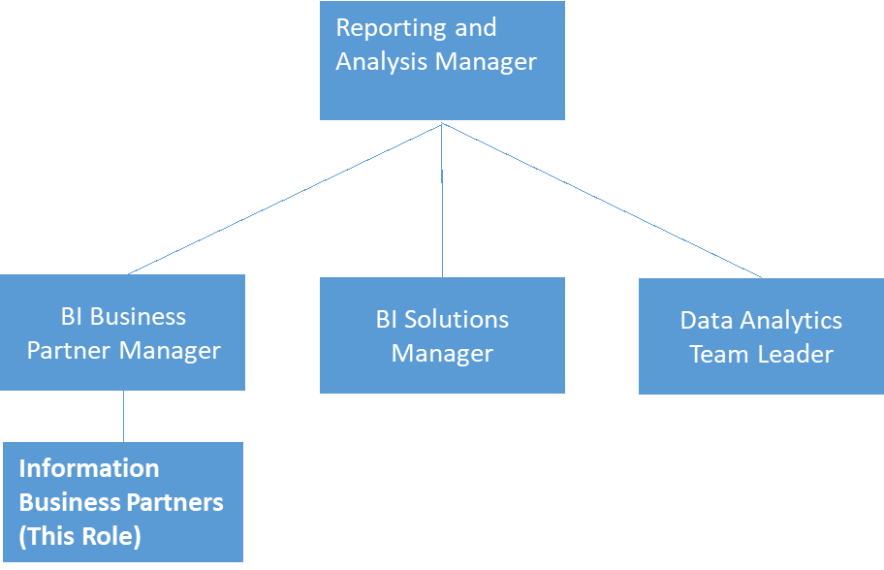

Job Summary

The Information Business Partner will work with and manage specific teams and stakeholders to ensure delivery of business intelligence and/or data related products, tools and techniques which support the ongoing operations and strategic direction of the organisation.

Reporting to the BI Business Partner Manager this role leads on stakeholder management and being the single point of contact for specific teams. The role includes developing proof of concepts, testing and understanding data with a view of advising the business and providing insights, development and promotion of statistical and information services, and presenting results to a varied audience.

Key Working Relationships

*Internal*

* All NHS Resolution staff

*External*

* External Stakeholders
* NHS Trusts

**Communication**

* Liaise with a range of staff and external bodies to identify their requirements and provide timely and relevant analysis and reports.
* Act as a point of reference on statistical and analytical techniques and methods, providing specialist advice and guidance throughout NHS Resolution.
* Assist other members of staff at NHS Resolution with data issues relating to their roles on both a regular and adhoc basis.
* Contribute to the production of written guidance, policies, procedures and frequently asked questions (or similar documents) for internal and external use.
* Create and maintain a stakeholder management plan, that sets out our approach to supporting the organization with meeting their objectives.
* Provide regular updates to the wider BI team highlighting business priorities and objectives
* Be the single point of contact for specific areas to advise on all data related needs.

**Planning and Organisational Skills**

* Provide analysis and insight to internal customers.
* Create, modify and review bespoke reports as and when required.
* Propose improvements to the collection and management of data within the organisation.
* Prepare and share stakeholder meetings notes, to include details of the key discussion points and lists of actions to be completed, detailing appropriate due dates
* Monitor, maintain and report on our ticket management systems (JIRA or equivalent) to help the team continuously work in an agile way.
* Prepare data and information to enable NHS Resolution to meet its legal obligations under the Freedom of Information Act (2005).

**Analytical and Judgmental Skills**

* Analyse, understand and interpret data from multiple sources to produce information and/or reports for NHS Resolution’s Senior Management Team, NHS Resolution Board, the Department of Health and Social Care (DHSC) and internal service delivery teams.
* Develop statistical and analytical methods for the production of regular statistically-based analysis for external stakeholders, (e.g. NHS Trusts, Department of Health and Social Care, Government Actuary Department). Support various internal stakeholders including individual staff performance analysis, risk management reports and financial reporting.
* Support various internal stakeholders, including individual staff performance analysis, risk management reports and financial reporting.
* Review reports on a regular basis to look for trends and provide insights to stakeholders. Develop internal databases where new requirements or functionality is required.

**Develop Self, Others and Team**

* Participate in the Annual Appraisal process, sourcing and undertaking training as identified in the Personal Development Plan.
* Provide specialist statistical or analytical training to staff across NHS Resolution as and when required.
* Contribute to internal and external publications including the Annual Report and Accounts, Annual Business Plan, eSafety and Learning materials and board reports.

**Information Management Responsibilities**

* Lead on the collection, analysis, production and presentation of internal and external reports for internal projects, external initiatives and the wider organisational performance.
* Provide specialist advice and guidance on statistical and information matters.
* Manage, develop and maintain internal databases.
* Have a detailed understanding of the case management systems used within NHS Resolution.
* Be the expert for specific areas to advise and assist their stakeholderts with the data related need
* Deliver training on reports and wider technical topics to ensure the business get the best out of the data
* Demonstrate creative thinking to utilize the data taking into account departmental priorities to develop reports that help the organization identify actionable insights

**Effort and Working Environment**

*Physical Effort*

* Office based post which requires the post holder to sit in a restricted position for the majority of the working day whilst undertaking analysis of data sets, writing reports, attending meetings etc; the post holder will be required to undertake light physical effort when carrying laptop and documents.

*Mental Effort*

* Occasional prolonged concentration is required to undertake detailed analysis of complex data sets and producing reports. Flexibility is required due to the unpredictable interruptions from staff and stakeholders on a daily basis.

*Emotional Effort*

* Rare exposure to emotional or distressing circumstances.

*Working Conditions*

* Normal office conditions with a requirement to use a computer for the majority of the working day. The post holder will be required to travel to attend external meetings on an occasional basis via public transport.

**Further Information**

1. The post holder must ensure that personal information for claimants, members of staff and all other individuals is accurate, up-to-date, kept secure and confidential at all times in compliance with the Data Protection Act/General Data Protection Regulations (2018) and the Common Law Duty of Confidentiality.
2. The post holder must follow the record keeping guidelines established by NHS Resolution to ensure compliance with the Freedom of Information Act (2000).
3. The post holder is expected to take responsibility for self-development on a continuous basis, undertaking on-the-job and other training as required.
4. The post holder is required to become familiar and comply with NHS Resolution’s policies and procedures.
5. The post holder must be aware of individual responsibilities under the Health and Safety at Work Act and identify and report, as necessary, any untoward accident, incident or potentially hazardous environment.
6. The post holder is expected to develop IT skills.
7. The post holder may be required to undertake duties at any location within NHS Resolution, in order to meet service needs.
8. This job description and person specification are intended as a guide to the main responsibilities and profile of the post and not as an exhaustive list of duties and tasks. The post holder may be required to undertake other duties appropriate to the post’s grades, which are not listed above, at the direction of a manager. The job description may be amended from time to time after consultation with the post holder.
9. NHS Resolution operates No Smoking Policy and No Alcohol policies.

**PERSON SPECIFICATION**

| **Category** | **Criteria** | **Essential (E) Desirable (D)** | **How tested\*** |
| --- | --- | --- | --- |
| **Education & Qualifications** | Educated to Masters’ Degree level or equivalent relevant experience in the analysis of data | E | A & I |
|  | Agile Project Management Qualification | D | A & I |
|  | Azure Fundamentals Basic | D | A & I |
| **Skills & Abilities** | Ability to collate, analyse, interpret and explain complex datasets | E | A & I |
| Intermediate level SQL coding | E | A & I |
| Intermediate level of Power BI | E | A & I |
| Advanced level of MS Excel | E | A & I |
| Intermediate Level of Word, Outlook, Visio , SharePoint and Powerpoint | E | A & I |
| Proven ability to work with operational teams to identify data problems and agree negotiated outcomes/actions | E | A & I |
| Ability to identify underlying problems by analysing information and suggest effective solutions | E | A, I & T |
| Extensive experience of working with a range of internal and external stakeholders to understand their reporting and analysis requirements | E | I |
| Ability to work and manage projects in an agile way |  |  |
| Ability to capture, document and update project requirements and outcomes | E | A & I |
| Ability to manage multiple workflows and achieve short deadlines. | E | A & I |
| Strong interpersonal and communication skills. | E | A & I |
| Ability to work independently and within a team. | E | I |
| Ability to work in an environment where there are frequent interruptions | E | A & I |
| Ability to work autonomously on a day to day basis, to work within broad occupational policies and targets and meet with manager at regular intervals to discuss progress, complex issues or areas of concern | E | A & I |
| Ability to demonstrate significant experience within a similar area of work | E | A & I |
| Ability to work over a prolonged period of time on an occasional basis | E | A & I |
| Experience of using Power BI for reporting and analysis | E | A & I |
| **Experience** | Experience of working on to tight deadlines | E | A & I |
| Experience of using a variety of analytical and statistical techniques | E | A, I & T |
| Extensive experience of analysing complex datasets effectively in a variety of settings, ideally within the NHS or equivalent | E | A & I |
| Experience of working with and combining data contained within different data sources | E | A, I & T |
| Experience of managing projects using JIRA | D | A & I |
|  | Experience of stakeholder engagement and management | E | A & I |
|  | Experience of working in occasionally highly challenging or highly pressurized circumstances. | D | A & I |
|  | An understanding of information governance and relevant legislation | E | A & I |
| **Knowledge & Understanding** | Knowledge and understanding of confidentiality within the workplace (particularly the NHS) | E | A & I |
| Knowledge and understanding of Freedom of Information Act (2000) | E | A & I |
|  | Knowledge and understanding of Data Protection Act/General Data Protection Regulations (2018) | E | A & I |
|  | Knowledge and understanding of Equality Act (2010) | E | A & I |
|  | Commitment to own personal and continued professional development | E | A & I |
| **Other** | Ability to work collaboratively as part of a team and be sensitive to the characteristics of working in an open plan office environment | E | I |
|  | Self-motivated and confident approach | E | I |
|  | Confident with a high level of drive, enthusiasm and commitment | E | I |
|  |  |  |  |

* A – application form; I – interview; T – test